Pentagonal Gyrobicupola

Definition
# Source: AI Source: Provided by: [Data Path: Persons Table -> ID Column: 1, Name_En Column: Motasem Essam] -> From: [ChatGPT] on [7/25/2026]
A Pentagonal Gyrobicupola is a convex polyhedron formed by joining two identical pentagonal cupolas along their regular decagonal bases, with one cupola rotated by ${36}^{∘}$ relative to the other.
It is the 31st Johnson solid (J31). It consists of 10 equilateral triangular faces, 10 square faces, and 2 regular pentagonal faces.
The relative rotation causes the square faces of one cupola to meet the triangular faces of the other, distinguishing it from the Pentagonal Orthobicupola (J30).

Geometric Structure
# Source: AI Source: Provided by: [Data Path: Persons Table -> ID Column: 1, Name_En Column: Motasem Essam] -> From: [ChatGPT] on [7/25/2026]
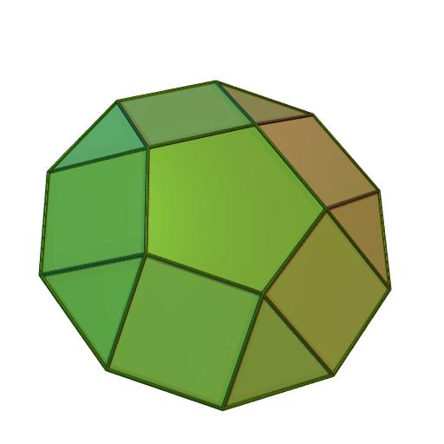
The solid consists of:
- Two opposite regular pentagonal faces.
- Ten equilateral triangular faces.
- Ten square faces.
- Twenty vertices and forty edges.
The two decagonal joining bases are internal to the construction and are not counted as external faces.

Face Composition
# Source: AI Source: Provided by: [Data Path: Persons Table -> ID Column: 1, Name_En Column: Motasem Essam] -> From: [ChatGPT] on [7/25/2026]
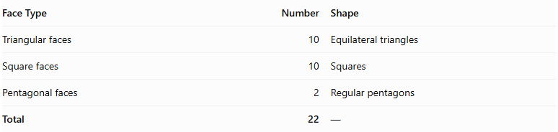
Face Type | Number | Shape
Triangular faces | 10 | Equilateral triangles
Square faces | 10 | Squares
Pentagonal faces | 2 | Regular pentagons
Total | 22 | —

Mathematical Properties
# Source: AI Source: Provided by: [Data Path: Persons Table -> ID Column: 1, Name_En Column: Motasem Essam] -> From: [ChatGPT] on [7/25/2026]
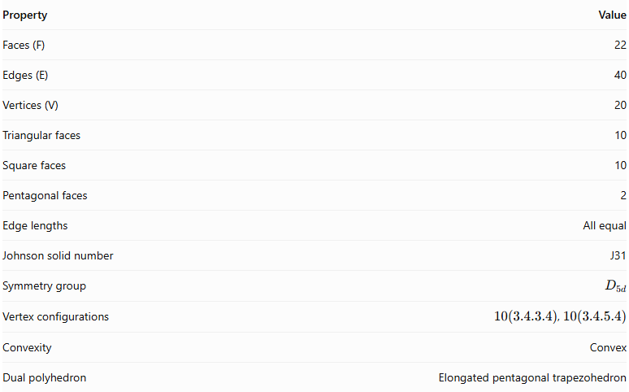
Property | Value
Faces (F) | 22
Edges (E) | 40
Vertices (V) | 20
Triangular faces | 10
Square faces | 10
Pentagonal faces | 2
Edge lengths | All equal
Johnson solid number | J31
Symmetry group | $$D_{5d}$$
Vertex configurations | $10(3.4.3.4)$, $10(3.4.5.4)$
Convexity | Convex
Dual polyhedron | Elongated pentagonal trapezohedron
Euler's formula:
$$V-E+F=20-40+22=2$$

Surface Area
# Source: AI Source: Provided by: [Data Path: Persons Table -> ID Column: 1, Name_En Column: Motasem Essam] -> From: [ChatGPT] on [7/25/2026]
For edge length $a$:
$$S=10(\frac{\sqrt{3}}{4}a^{2})+10a^{2}+2(\frac{5a^{2}}{4}cot\frac{π}{5})$$
Simplifying:
$$\boxed{S=\frac{20+\sqrt{100+10\sqrt{5}+10\sqrt{75+30\sqrt{5}}}}{2}a^{2}}$$
For unit edge length:
$$S≈17.7711$$

Volume
# Source: AI Source: Provided by: [Data Path: Persons Table -> ID Column: 1, Name_En Column: Motasem Essam] -> From: [ChatGPT] on [7/25/2026]
$$\boxed{V=\frac{5+4\sqrt{5}}{3}a^{3}}$$
For unit edge length:
$$V≈4.6481$$

Geometric Characteristics
# Source: AI Source: Provided by: [Data Path: Persons Table -> ID Column: 1, Name_En Column: Motasem Essam] -> From: [ChatGPT] on [7/25/2026]
- Convexity: It is a convex polyhedron.
- Face regularity: All faces are regular polygons.
- Edge uniformity: All 40 edges have equal length.
- Vertex configuration: It has two types of vertex arrangements:
- 10 vertices with configuration $3.4.3.4$.
- 10 vertices with configuration $3.4.5.4$.
- Symmetry: It has $D_{5d}$ symmetry, with fivefold rotational symmetry and dihedral reflection-related symmetry.
- Duality: Its dual is the elongated pentagonal trapezohedron.

Construction of Pentagonal Gyrobicupola

Geometric Instruments Used
# Source: AI Source: Provided by: [Data Path: Persons Table -> ID Column: 1, Name_En Column: Motasem Essam] -> From: [ChatGPT] on [7/25/2026]
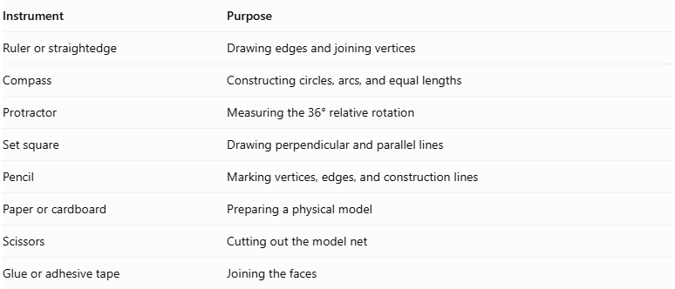
Instrument | Purpose
Ruler or straightedge | Drawing edges and joining vertices
Compass | Constructing circles, arcs, and equal lengths
Protractor | Measuring the 36° relative rotation
Set square | Drawing perpendicular and parallel lines
Pencil | Marking vertices, edges, and construction lines
Paper or cardboard | Preparing a physical model
Scissors | Cutting out the model net
Glue or adhesive tape | Joining the faces

Instrument-Based Construction Procedures

Construct the First Pentagonal Cupola
# Source: AI Source: Provided by: [Data Path: Persons Table -> ID Column: 1, Name_En Column: Motasem Essam] -> From: [ChatGPT] on [7/25/2026]
- Draw a regular decagon using a compass, ruler, and protractor.
- Construct a regular pentagon above the decagonal base, following the standard pentagonal cupola arrangement.
- Around the decagon, construct ten alternating lateral faces:
- Five equilateral triangular faces.
- Five square faces.
- Ensure that the triangular and square faces have matching edge lengths.
- Check that the pentagonal top is correctly connected to the lateral faces.

Construct the Second Pentagonal Cupola
# Source: AI Source: Provided by: [Data Path: Persons Table -> ID Column: 1, Name_En Column: Motasem Essam] -> From: [ChatGPT] on [7/25/2026]
- Draw another regular decagon congruent to the first.
- Construct a congruent regular pentagonal top.
- Construct five equilateral triangular and five square lateral faces.
- Ensure that all corresponding dimensions match the first cupola.
- Keep the second cupola separate until the rotational arrangement is established.

Rotate the Second Cupola
# Source: AI Source: Provided by: [Data Path: Persons Table -> ID Column: 1, Name_En Column: Motasem Essam] -> From: [ChatGPT] on [7/25/2026]
- Identify the center of the shared decagonal base.
- Mark the required rotation angle:
$$α={36}^{°}$$
- Rotate the second cupola by ${36}^{°}$ around the central axis of its decagonal base.
- Check that the two decagonal bases remain congruent and can be matched edge-to-edge.

Join the Two Cupolas
# Source: AI Source: Provided by: [Data Path: Persons Table -> ID Column: 1, Name_En Column: Motasem Essam] -> From: [ChatGPT] on [7/25/2026]
- Place the two decagonal bases opposite one another.
- Match the vertices and edges of the shared decagons.
- Join the cupolas in the gyro arrangement.
- Ensure that the square faces of each cupola meet the triangular faces of the other along the joining region.
- Treat the shared decagonal bases as internal faces.
- Check that the exterior consists of ten equilateral triangles, ten squares, and two regular pentagons.

Complete the Solid Drawing
# Source: AI Source: Provided by: [Data Path: Persons Table -> ID Column: 1, Name_En Column: Motasem Essam] -> From: [ChatGPT] on [7/25/2026]
- Draw the two exposed regular pentagonal bases at opposite ends.
- Complete the ten triangular and ten square lateral faces.
- Use solid lines for visible edges.
- Use dashed lines for hidden edges when necessary.
- Verify that the final solid has 22 faces, 40 edges, and 20 vertices.
Construction restriction: This procedure uses geometric instruments, angle measurements, and geometric relationships. It does not use coordinate-based construction.

Related Geometric Solids
# Source: AI Source: Provided by: [Data Path: Persons Table -> ID Column: 1, Name_En Column: Motasem Essam] -> From: [ChatGPT] on [7/25/2026]
- Pentagonal Cupola (J5): The component solid used to construct the Pentagonal Gyrobicupola.
- Pentagonal Orthobicupola (J30): Formed by joining two pentagonal cupolas without relative rotation.
- Square Gyrobicupola (J29): A related gyrobicupola formed from two square cupolas.
- Elongated Pentagonal Gyrobicupola (J39): Formed by inserting a decagonal prism between two pentagonal cupolas in gyro orientation.
- Elongated Pentagonal Trapezohedron: The dual polyhedron of the Pentagonal Gyrobicupola.

Main Classification
# Source: AI Source: Provided by: [Data Path: Persons Table -> ID Column: 1, Name_En Column: Motasem Essam] -> From: [ChatGPT] on [7/25/2026]
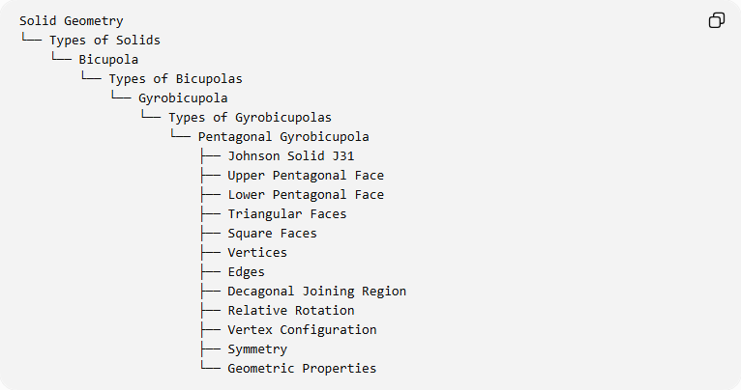
Solid Geometry
└── Types of Solids
└── Bicupola
└── Types of Bicupolas
└── Gyrobicupola
└── Types of Gyrobicupolas
└── Pentagonal Gyrobicupola
├── Johnson Solid J31
├── Upper Pentagonal Face
├── Lower Pentagonal Face
├── Triangular Faces
├── Square Faces
├── Vertices
├── Edges
├── Decagonal Joining Region
├── Relative Rotation
├── Vertex Configuration
├── Symmetry
└── Geometric Properties

Important Distinction
# Source: AI Source: Provided by: [Data Path: Persons Table -> ID Column: 1, Name_En Column: Motasem Essam] -> From: [ChatGPT] on [7/25/2026]
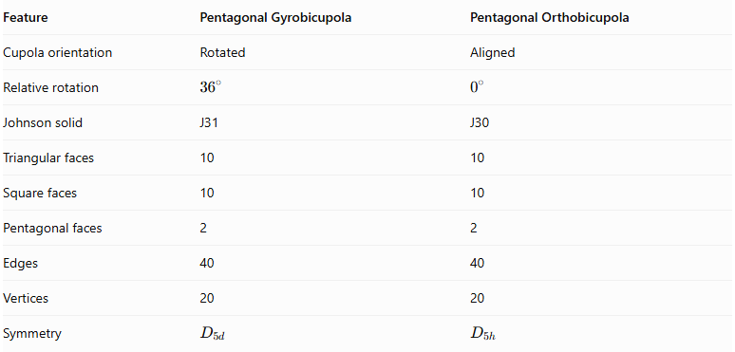
Feature | Pentagonal Gyrobicupola | Pentagonal Orthobicupola
Cupola orientation | Rotated | Aligned
Relative rotation | $${36}^{∘}$$ | $$0^{∘}$$
Johnson solid | J31 | J30
Triangular faces | 10 | 10
Square faces | 10 | 10
Pentagonal faces | 2 | 2
Edges | 40 | 40
Vertices | 20 | 20
Symmetry | $$D_{5d}$$ | $$D_{5h}$$
Both solids have identical face compositions and mathematical counts, but differ in the relative orientation of their two cupolas.

Key Points
# Source: AI Source: Provided by: [Data Path: Persons Table -> ID Column: 1, Name_En Column: Motasem Essam] -> From: [ChatGPT] on [7/25/2026]
- The Pentagonal Gyrobicupola is Johnson solid J31.
- It is constructed from two pentagonal cupolas joined at their decagonal bases.
- One cupola is rotated ${36}^{∘}$ relative to the other.
- It has 10 equilateral triangles, 10 squares, and 2 regular pentagons.
- It has 22 faces, 40 edges, and 20 vertices.
- Its dual is the elongated pentagonal trapezohedron.

Conclusion
# Source: AI Source: Provided by: [Data Path: Persons Table -> ID Column: 1, Name_En Column: Motasem Essam] -> From: [ChatGPT] on [7/25/2026]
The Pentagonal Gyrobicupola is a convex Johnson solid formed by joining two pentagonal cupolas with a ${36}^{∘}$ relative rotation. Its combination of triangular, square, and pentagonal faces produces a polyhedron with 22 faces, 40 edges, and 20 vertices.

